**Name: Debjyoti Sarkar Sumonta**

**Student ID: 22341019**

**CSE321 Section 5**

***C Program***

**Task 1**

#include <stdio.h>

struct Item {

int quantity;

float unit_price;

};

int main() {

struct Item paratha, vegetable, water;

int num_people;

float total_bill, individual_payment;

printf("Quantity of Paratha: ");

scanf("%d", &paratha.quantity);

printf("Unit price of Paratha: ");

scanf("%f", &paratha.unit_price);

printf("Quantity of Vegetables: ");

scanf("%d", &vegetable.quantity);

printf("Unit price of Vegetables: ");

scanf("%f", &vegetable.unit_price);

printf("Quantity of Mineral Water: ");

scanf("%d", &water.quantity);

printf("Unit price of Mineral Water: ");

scanf("%f", &water.unit_price);

total_bill = (paratha.quantity * paratha.unit_price) + (vegetable.quantity * vegetable.unit_price) + (water.quantity * water.unit_price);

printf("Enter the number of people: ");

scanf("%d", &num_people);

individual_payment = total_bill / num_people;

printf("Each person will pay: %.2f tk\n", individual_payment);

return 0;

}

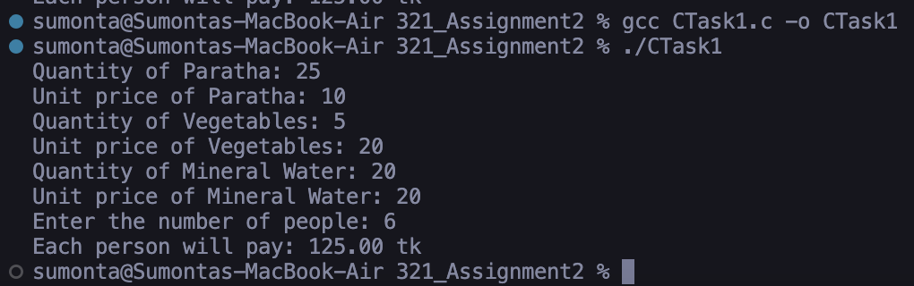

**Task 2**

#include <stdio.h>

int isPerfect(int num) {

int sum = 0;

for (int i = 1; i < num; i++) {

if (num % i == 0) {

sum += i;

}

}

return sum == num;

}

int main() {

int start, end;

printf("Enter two intervals: ");

scanf("%d %d", &start, &end);

for (int i = start; i <= end; i++) {

if (isPerfect(i)) {

printf("%d\n", i);

}

}

return 0;

}

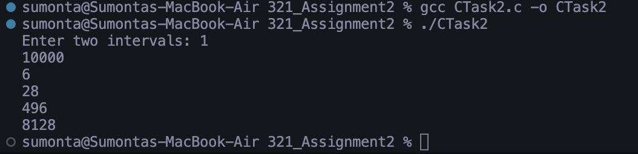

***System Calls***

**Task 1**

#include <stdio.h>

#include <stdlib.h>

#include <string.h>

int main(int argc, char *argv[]) {

FILE *file;

char input[100];

if (argc != 2) {

printf("Usage: %s <filename>\n", argv[0]);

return 1;

}

file = fopen(argv[1], "a");

if (file == NULL) {

printf("Error opening file!\n");

return 1;

}

while (1) {

printf("Enter a string (-1 to stop): ");

fgets(input, 100, stdin);

input[strlen(input) - 1] = '\0';

if (strcmp(input, "-1") == 0) {

break;

}

fprintf(file, "%s\n", input);

}

fclose(file);

return 0;

}

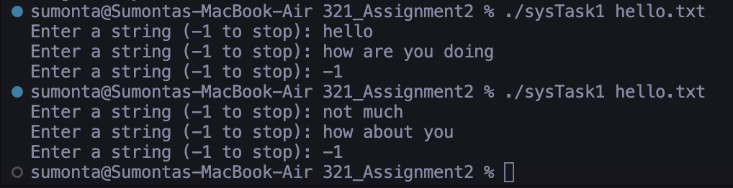

**Task 2**

#include <stdio.h>

#include <unistd.h>

#include <sys/wait.h>

int main() {

pid_t pid1, pid2;

pid1 = fork();

if (pid1 == 0) {

pid2 = fork();

if (pid2 == 0) {

printf("I am grandchild\n");

} else {

wait(NULL);

printf("I am child\n");

}

} else {

wait(NULL);

printf("I am parent\n");

}

return 0;

}

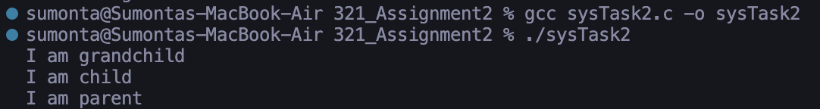

***Threads***

**Task 1**

#include <stdio.h>

#include <pthread.h>

void* runThread(void* arg) {

int id = *(int*)arg;

printf("Thread-%d running\n", id);

printf("Thread-%d closed\n", id);

pthread_exit(NULL);

}

int main() {

pthread_t threads[5];

int ids[5];

for (int i = 0; i < 5; i++) {

ids[i] = i + 1;

pthread_create(&threads[i], NULL, runThread, &ids[i]);

pthread_join(threads[i], NULL);

}

return 0;

}

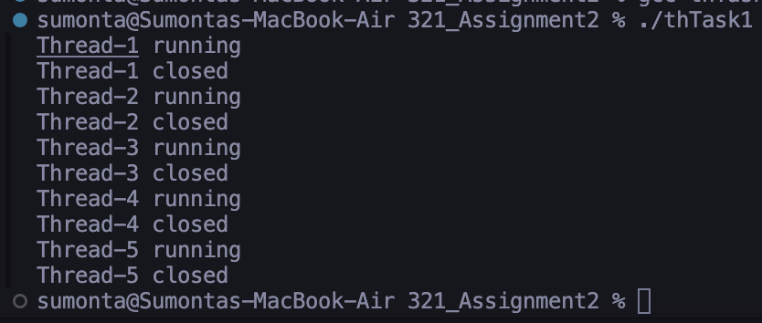

**Task 2**

#include <stdio.h>

#include <pthread.h>

void* printNumbers(void* arg) {

int id = *(int*)arg;

for (int i = id * 5 + 1; i <= id * 5 + 5; i++) {

printf("Thread %d prints %d\n", id, i);

}

pthread_exit(NULL);

}

int main() {

pthread_t threads[5];

int ids[5];

for (int i = 0; i < 5; i++) {

ids[i] = i;

pthread_create(&threads[i], NULL, printNumbers, &ids[i]);

pthread_join(threads[i], NULL);

}

return 0;

}

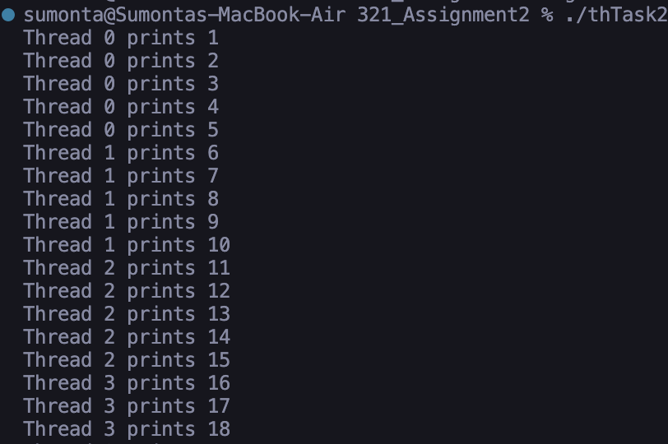

**Task 3**

#include <stdio.h>

#include <stdlib.h>

#include <pthread.h>

#include <string.h>

int ascii_sum[3];

void* calculate_ascii_sum(void* arg) {

char* name = (char*)arg;

int sum = 0;

for (int i = 0; i < strlen(name); i++) {

sum += name[i];

}

int* result = (int*)malloc(sizeof(int));

*result = sum;

pthread_exit(result);

}

void* compare_sums(void* arg) {

if (ascii_sum[0] == ascii_sum[1] && ascii_sum[1] == ascii_sum[2]) {

printf("Youreka\n");

} else if (ascii_sum[0] == ascii_sum[1] || ascii_sum[1] == ascii_sum[2] || ascii_sum[0] == ascii_sum[2]) {

printf("Miracle\n");

} else {

printf("Hasta la vista\n");

}

pthread_exit(NULL);

}

int main() {

pthread_t threads[4];

char* usernames[3] = {"Jamal", "Hakim", "Noor"};

for (int i = 0; i < 3; i++) {

pthread_create(&threads[i], NULL, calculate_ascii_sum, usernames[i]);

}

for (int i = 0; i < 3; i++) {

int* result;

pthread_join(threads[i], (void**)&result);

ascii_sum[i] = *result;

free(result);

}

pthread_create(&threads[3], NULL, compare_sums, NULL);

pthread_join(threads[3], NULL);

return 0;

}

